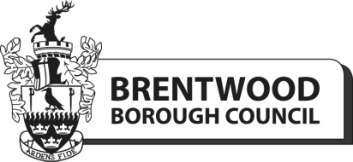

Risk Assessment Pro Forma – Events 2024

It is a requirement by the organising team that a risk assessment is completed by each individual pitch holder or activity provider for selected event in 2024. Once you have completed the risk assessment, please return it to events@brentwood.gov.uk

Please note that pitch holders and activity providers are responsible for all their own stalls & equipment. There will be no tables, chairs, generators or gazebos provided by the organising team.

Guidance notes

When completing the Risk Assessment please identify any potential risks that you are aware of relating to your particular stall or activity.
- Identify the general area of concern – e.g. selling of food, trip hazard, risk of fire, falling or collapsing stall
- Identify the particular Hazard– potential harmful ingredients such as nuts in the food.
- What are putting in place to minimise that hazard – e.g. labelling of all ingredients so that the public are aware
- Identify who would be at risk – i.e. the public, a contractor, stall holder
- What is the worst outcome if this happens? e.g. injury, death
- What is the probability of this happening i.e. very likely, remote
- Do you consider this to be an acceptable risk at this time? – Yes or No
- If no what further actions will you be taking to further minimise this risk.

If you have any questions, please contact Community Services Team on 01277 312764 or email events@brentwood.gov.uk

Risk Assessment – Events 2024

Name of event __________________________________________________

Activity/Area of Concern | Hazard Identified | Existing Control Method | Person at risk | Worst Outcome | Probability

Name of Organisation_________________________________ Date completed________________________

