Jo
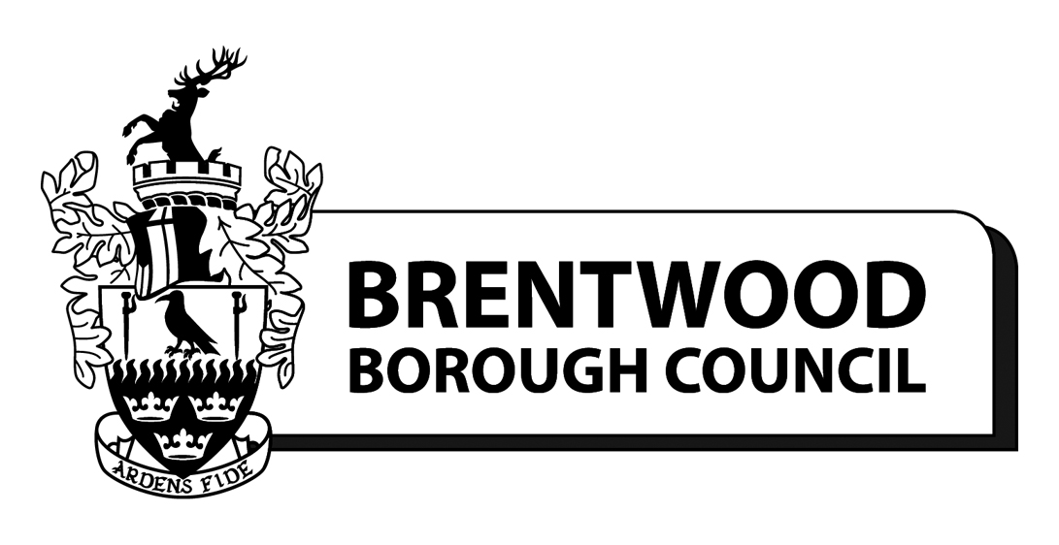

Senior Building Control Surveyor
Permanent Position
Full Time - 37 hours per week
Grade I (SCP 41 - 45) - £41,192 - £45,317 p.a.
Closing Date for accepting applications: Sunday 10 October 2021
Interviews Dates – TBC

(Starting salary dependent upon skills and qualifications, progression subject to satisfactory performance)

Are you a Senior Building Control Surveyor looking for a new challenge?

We are looking for an experienced and enthusiastic individual with a construction related qualification and a full member of the RICS, CABE or CIOB to join our Building Control Team. We are committed to providing a customer focused service that will maximize business opportunities. Using your knowledge and experience, you will be working on all aspects of building control including checking plans, advising, and liaising with the public, builders, architects and other professionals regarding the Building Regulations and allied legislation.

If you are self-motivated, able to work effectively within a team and can write clear, concise reports, this may be the role for you!

Further information on this role can be found in the Job Description and Person Specification.

As a Council we offer flexible working arrangements, including home working, generous pension contributions and we will pay for your professional membership fees.

To apply for this vacancy using our quick and easy on-line application method, click on this link:

Link to Apply

For an informal discussion please contact Gary Price-Sampson on 07850 590694.

Brentwood Council is committed to equal opportunities and welcomes applications from all sections of the community. People with disabilities will be offered an interview where they meet the Essential Criteria on the Person Specification.

